**Ready to listen, ready to learn together**

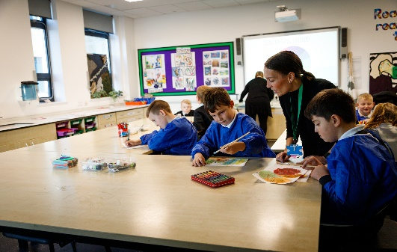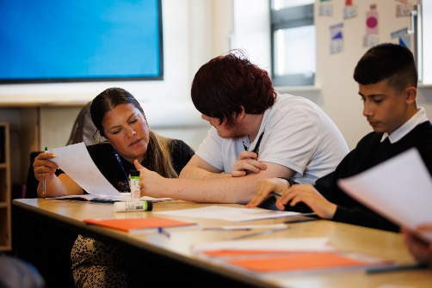

*Options prospectus 2024 - 2025*

***Happy, confident, independent learners***

***prepared for adulthood***

**Introduction.**

In this prospectus you will find the wide range of options we offer to the students here at Epinay, we strive to give our students happiness, confidence and independence in order to prepare them for adulthood.

The options will be in 2 blocks both studied for 1 year, over 2 afternoons per week.

Our options are aimed at wellbeing (personal interests which may be developed more as a future hobby) and pathways (future career interests)

Interests in vocational placements are welcomed and will be considered if we have capacity. Students can express interest in vocational placements, school will endeavour to accommodate where possible.

Students will choose 2 options at the end of year 9, then repeat the process and choose 2 more at the end of year 10. This means students will work towards 4 optional qualifications during phase 4.

The options are outlined below.

|  |  |
| --- | --- |
| **Block 1** | **Block 2** |
| Photography | Home Cooking Skills |
| Design Technology | Art |
| Sport | Performing Arts |
| History | History |
| Horticulture | Horticulture |
| Life Skills | Life Skills |
| ICT |  |
| Enterprise skills (not qualification driven) practical course making products to sell – develops practical and business skills |  |
| Life skills (Bespoke programme for selected students) – students can pick this option but we will also contact the parents of those students we feel would be appropriate for this programme | |

The following pages of the prospectus give more details on each option, the staff members delivering, what you will study, assessment and careers pathways information. Please note students cannot repeat options they have already taken in year 10.

An options choice form will be sent out alongside this prospectus for you to complete.



***Happy, confident, independent learners***

***Ready for adulthood***

**How do I choose?**

You might feel nervous about choosing what to study for your future. Perhaps you don't know what you want to do. Or you have some ideas but want to make sure you're making the right choices.

* Don't just choose what your friends are doing. It’s your life – so choose the subjects that work best for YOU.
* Choose subjects or options which you’re good at and which you enjoy.
* Have a look at some new subjects that interest you.
* Look into what each subject/qualification involves.
* Could a subject help with your future career plans?
* No-one expects you to have your future plans all sorted out at age 14. If you’re still not sure about your future plans, choose subjects you enjoy.

**Who can help you?**

* Your parents/carers, family and friends probably know you better than anyone. They can help you focus on what you’re good at / your likes and dislikes/what you’re like as a person. Share your ideas with them – they might have some useful suggestions.
* Teachers at school know what’s involved in the subjects they teach and know how you like to study.
* Connexions can help you explore all your options and give impartial information

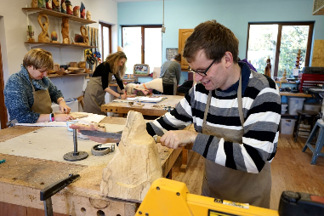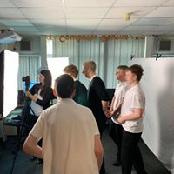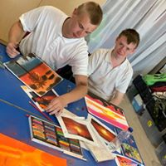

**Introduction.**

The introductory Award or Certificate in Art and Design is an exciting course in which students can explore woodwork, the use of tools and equipment used for carpentry and joinery. Students will develop skills within this area, have the opportunity to visit different construction/engineering venues and participate in a variety of skill-based workshops.

**What you will study**

During the course, students will collect a portfolio of evidence from the design stage to the make and evaluate stage. Attending and reviewing various practical venues and workshops. Researching jobs and career pathways within the design technology industry and developing practical skills in a workshop.

Design Technology

Mrs Duckworth

Features of subject

* Practical with some written work
* Exam and coursework

**Assessment**

Students showcase their finished work at a school exhibition, which is then assessed and externally moderated. Following successful completion of the course at the required standard students will achieve a BTEC L1 Introductory Award or Certificate in Art and Design.

**Pathways**

Students could go on to study a level 1 or 2 BTEC qualification or GCSE within Art and Design. Qualifications in Art and Design are required for a variety of careers such as craft, carpentry, joinery and other construction trades.

Designers, Interior Designers and Set and Exhibit Designers.

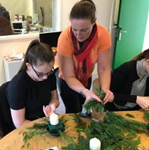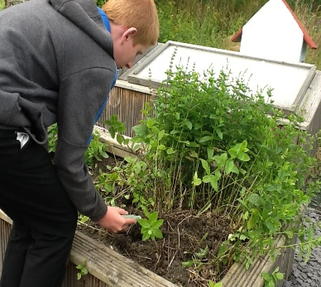

**Assessment**

Students are assessed via a portfolio of work. Following successful completion of the course at the required standard students will achieve a NOCN Level 1 Award or Certificate in Horticulture.

**Pathways**

Students could go on to study a level 2 NOCN qualification or pursue a career in practical environments such as ground maintenance, landscape design or garden centres.

**What you will study**

Horticulture is about using science to propagate and grow produce. You will learn about lifecycle of plants and flowers, what makes things grow, prevention of disease/pest infestation and health and safety within this environment. You will develop skills via practical based tasks and through additional responsibilities such as the maintenance of the school garden

**Introduction.**

In this option you will learn how to use and maintain garden/floristry hand tools and develop an understanding of soil, plants/flowers, propagation, pruning, weeding, plant/flower growing and pest control whilst being respectful of wildlife.

Horticulture

Mrs Mitchell

Features of subject

* Practical learning with some written work.
* Coursework Assessed

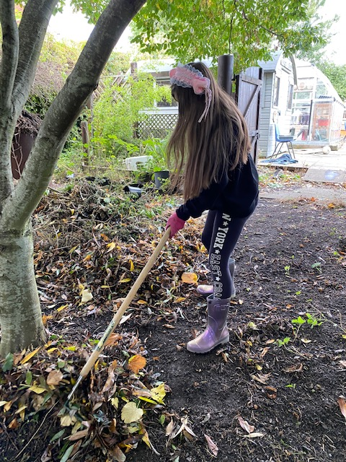



**Assessment**

Students are assessed via a portfolio of work and one externally set task (practical exam). Following successful completion of the course at the required standard student will achieve an Entry Level Qualification in Art and Design (Photography).

**Pathways**

Students could go on to study a level 1 or 2 BTEC qualifications or GCSE. Qualifications in photography are required for a variety of careers such as Advertising Art Director, Animator, Cinematographer, Community Arts Worker, Editorial Assistant.

Photography

Mrs Brewis

Features of subject

* Practical with some written work
* 2 afternoons per week
* Coursework



**What you will study**

Photography is not just about taking photographs! Within this option you will study documentary photography, Photo-journalism, Studio photography, location photography, experimental imagery, installation and moving image.

**Introduction.**

In this option you will study the uses of photography in digital media, social media and branding. You will develop a unique skillset in different mediums such as film, photo editing and traditional photography.



**What you will study**

Students will study Crime and Punishment, The Viking Age c. 750–c. and choose either a site or an individual to study and complete two pieces of work: A 150-word biography (of the person) or guide (to the site) and a 250-word explanation of the importance and impact of their site or individual over time.

**Introduction.**

Entry Level Certificate in History provides a fantastic curriculum for learners to ignite and engage their passions and interests. The content aims to create independent learners, critical thinkers and decision makers – all personal assets that can make them stand out as they progress to further education and/or the workplace.

History

Mrs Trotter

Features of subject

* Written Coursework Externally Moderated

**Assessment**

Students are assessed via a portfolio of work. Following successful completion of the course at the required standard students will achieve an OCR Entry Level History qualification.

**Pathways**

Students may choose to complete further qualifications in history such as level 1 or GCSE courses. Skills developed such as investigation, critical thinking, motivation, confidence and teamwork are skills that can be used in any further education, training or job opportunity that a pupil may desire to undertake.

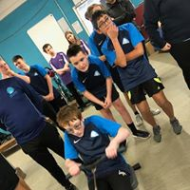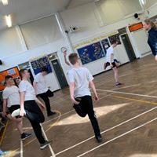

**What you will study**

The sporting option is not simply playing games or having practical time. The course requires you to research and complete some written tasks around leisure opportunities in the local area, look at different jobs in sport and how suitable you are for them, as well as developing practical skills needed for a range of both individual and team sports. You will be expected to develop your knowledge of what makes a good leader and practise your leadership skills by planning and delivering short practical sessions.

**Assessment**

Students are assessed by via a portfolio of practical and written work. Following successful completion of the course at the required standard students will achieve an OCR Entry Level PE qualification. Students who display leadership skills will also complete a Sports Leaders UK Level 1 qualification, where they will submit written tasks and demonstrate 1 hour of practical leadership.

**Pathways**

Students could go on to study a level 2 BTEC qualification or take part in a National Governing Body Coaching award in specific sports. Qualifications in sport are required for a variety of careers such as being a sports coach, outdoor education instructor, personal trainer or working in local gyms and leisure services.

**Introduction**

In this option you will study how sport is an important part of individuals’ health and well-being, while also considering the role sport has in society with regard to job opportunities in the health and leisure industry. You will develop leadership skills which can be used in later working life.

Sport

Miss Mitchell

Features of subject

* Portfolio of practical assignments
* Practical sessions in a range of sports
* Coursework assessed

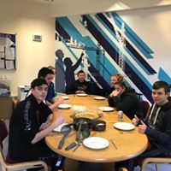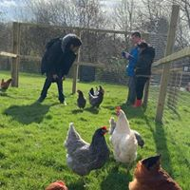

**Introduction.**

In this option you will study a broad range of units aimed at preparing young people for life as an independent adult. It will develop and encourage confidence, independence, safety and resilience.

**What you will study**

Within this option you will study units how to run a household, access facilities in the local area; including welfare support, using public transport, care for small animals, skills for work and prepare and cook basic meals.

Life & Living Skills

Mrs Willis & Mrs Brewis

Features of subject

* Practical with some written work
* Coursework assessed

**Assessment**

Students are assessed via a portfolio of work per unit. Following successful completion of the course at the required standard, students will achieve an Entry Level qualification in Life and Living Skills at Award, Certificate, Extended Certificate or Diploma Level 1, 2, or 3.

**Pathways**

This qualification is aimed at pupils who may not yet have a defined pathway in mind, it gives a flavour of a range of subject areas that students may then wish to study in greater depth or pursue for a career, it develops key skills for life.

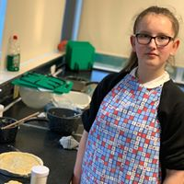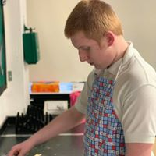

Home Cooking Skills

Miss Mather

Features of subject

* Practical with some written work
* Assessment and coursework

**Assessment**

Students are assessed via a portfolio of work and one set task of being able to plan, prepare and cook a dish. Following successful completion of the course at the required standard students will achieve a Level 1 BTEC Award in Home Cooking Skills.

**Pathways**

Students could go on to study a level 1 or 2 BTEC qualification or GCSE. Qualifications in cooking are required for a variety of careers such as chef, restaurant worker, kitchen staff, restaurant owner, food manager and catering assistant.

**What you will study**

Being able to cook is an essential life skill! Within this option you will learn lots of cooking skills, be able to read recipes, plan meals and cook a different dish each week. Cooking is fun!

**Introduction.**

In this option you will gain knowledge, skills and confidence to enjoy planning and cooking meals at home. It will encourage you to use all of the skills learnt to cook recipes for yourselves and your families.



**Assessment**

Students are assessed via a portfolio of work which includes evidence of planning, researching using, applying and making.  Following successful completion of the course at the required standard, students will achieve a NOCN Entry Level 3 Certificate in Preparing for Further Learning or Employment.

**Pathways**

Students could go on to study a level 1 or 2 BTEC qualification or GCSE within Art and Design. Qualifications in Art and Design are required for a variety of careers such as Craft and Fine Artists, Textile Designers, Fashion.

**What you will study**

During the course, students will collect evidence in a sketchbook of their experiences of: Actively participating in and developing skills within their chosen field (e.g. painting, sculpture, drawing, printing, stitching, felting) Attending and reviewing various art venues and workshops. Researching the career and work of inspirational artists.

**Introduction.**

Art and Design is an exciting course in which students can explore fine art, textile, 3D, sculpting, drawing and painting. Students will develop skills within their area, have the opportunity to visit different art venues in the local area and also participate in a variety of skill-based workshops.

Art

Mrs Brown

Features of subject

* Practical with some written work
* Exam and coursework

**What you will study**

* You will learn to apply knowledge and understanding and a range of techniques to identify the ICT requirements to produce an appropriate solution to practical problems, situations and contexts to generate successful outcomes You will use ICT skills with increasing levels of independence and apply knowledge, skills and understanding within familiar contexts, drawing on a range of approaches to obtain answers to problems.

**Assessment**

Students are assessed via a portfolio of work and a formal computerised exam. Following successful completion of the course at the required standard students will achieve a NOCN Entry Level or Level 1 Certificate in Functional ICT.

**Pathways**

Students could go on to study a level 2 BTEC qualification or GCSE. Qualification in ICT. These are required for a variety of careers such as computer programming, secretarial or administration work, data base or systems analyst type work.

**Introduction.**

This option will equip learners with the skills and confidence to apply, combine and adapt their ICT knowledge and problem solving skills to new situations in their life and work in a range of contexts and for various purposes

ICT

Mr Robson

Features of subject

* Computer based work
* Formal exam and coursework

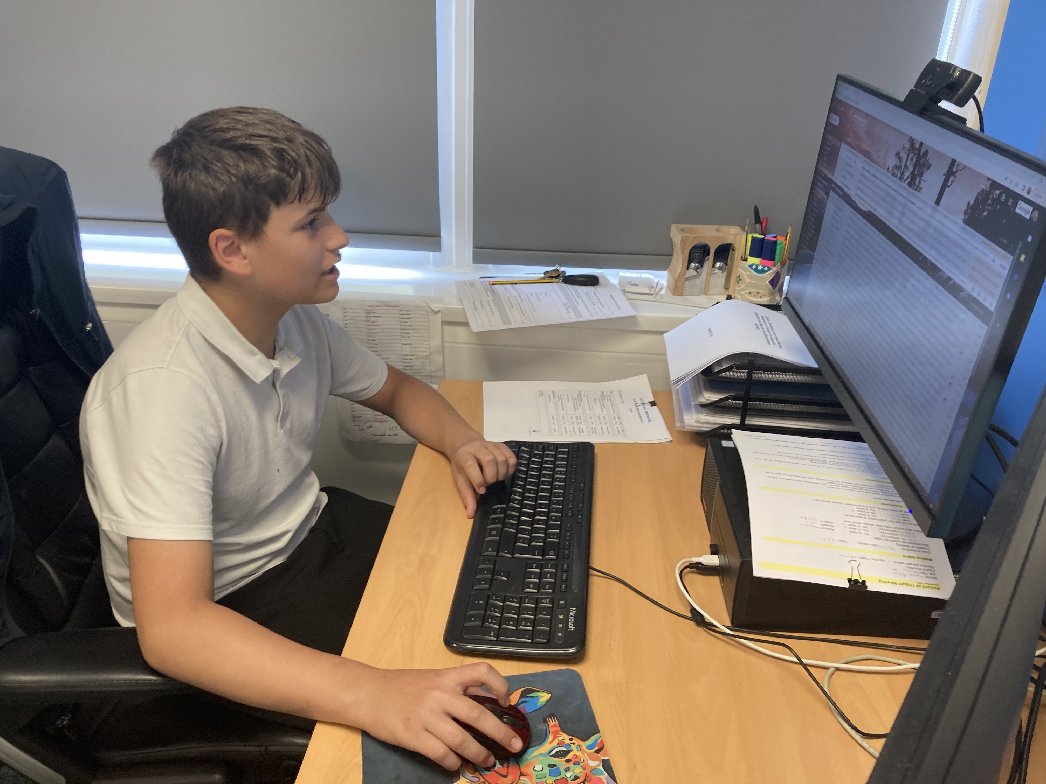

**Introduction.**

In this option, you will develop instrumental and performance skills through a variety of topics and mediums. You will explore different genres of music and work together to put on a musical and dramatic performance. You will reflect on your work through evaluation and setting targets.

**Assessment**

Students are assessed via a portfolio of work which includes evidence of planning, rehearsing, performing and evaluating music and drama.  Following successful completion of the course at the required standard, students will achieve an Arts Award Bronze or Silver qualification.

**Pathways**

Students could go on to study a BTEC qualification or GCSE. Qualifications in music and drama can be used as a stepping stone for a variety of creative careers, but specifically a musician, actor, stage/costume work, music therapist, working in the media (TV or radio) or music merchandising.

**What you will study**

You will study and complete a mandatory unit on further learning and employment then study four topics on a carousel basis. You will musical performance as a group and solo and performing arts skills in theory and practice. You will put on a show!

Performing Arts

Mrs Dunn

Features of subject

* Practical, developing instrumental, vocal skills and drama skills
* Written/typed work
* Assessed performance and coursework

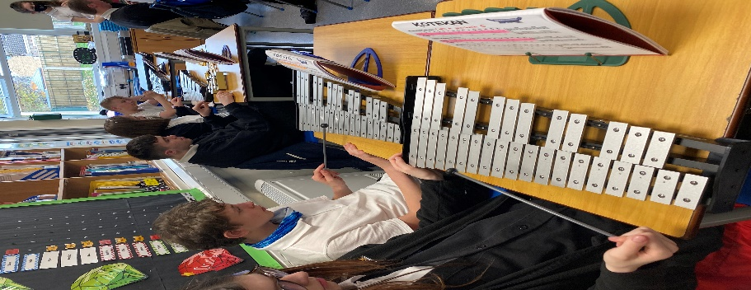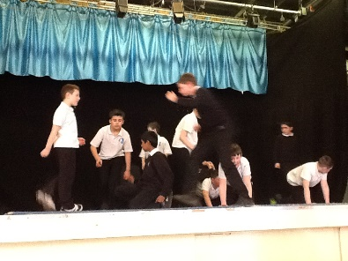

**Horticulture**

Horticulture includes a variety of jobs; maintaining gardens, landscaping, tree felling and nurseries/garden centres.

**Gardeners and Landscape Gardeners**

The typical starting salary is £18,574 and can progress up to £31,179 as they progress through their career.

Typical tasks of the role include:

* Performs general garden maintenance
* Prepares or interprets garden design plans
* Moves soil to alter surface contour of land using mechanical equipment and constructs paths, rockeries, ponds and other features.

**Hairdressing**

The typical roles of a Hairdresser or Barber include:

* Demonstrates, sells and recommends hair care products to clients and advises them on hair care
* Ensures hair products are stored and used appropriately and observes relevant health and safety features
* Maintains client records and keeps up-to-date with new products, styles and techniques.
* Collects payment, arranges appointments and cleans and tidies salon
* Shaves and trims beards and moustaches
* Cuts and trims hair using scissors, clippers, razors and combs.
* Washes, conditions, bleaches, tints or dyes hair and provides necessary basic scalp treatments

Those new workers entering the profession typically start on around £15,725 while highly experienced Hairdressers can earn around £23,670.

**Labour Market Information**

Within South Tyneside and wider North East, there are a variety of different employment sectors you might enter once you leave school.

Approximately 150,300 people live in South Tyneside. 93,400 of those residents are of working age and 63,400 are currently employed. Typical employment routes are as follows.

**Sport**

Careers in Sport can vary from teaching and education roles, through to leisure management and support through to professional sports players and athletes. Some of those roles include:

**Sports Coaches**

Sports Coaches, Instructors or Officials who earn between £16,765 and £40,602.

**Care**

Workers within the Care sector provide care and support services for children, healthcare patients and the elderly, they also can be responsible for administering social programmes.

**Social Workers**

These workers earn between £24,669 and £51,064.

Typical tasks of the role include:

* Participates in training and supervision.
* Gives evidence in court.
* Keeps case records, prepares reports and participates in team meetings.
* Organises support and develops care plans to address service users.
* Arranges for further counselling or assistance in the form of financial or material help.
* Undertakes and writes up assessments to specified standards.
* Interviews individuals and groups to assess and review the nature and extent of difficulties.
* Liaises with other health and social care professionals and agencies to identify those in need and at risk within the local community.

**Nursing Assistants**

These workers earn between £18,103 and £30,950.

Typical duties of the role include:

* Changes bed linen makes beds and tidies wards.
* Assists patients in washing, dressing, toiletry activities and general mobility.
* Distributes and serves food, assists patients in feeding and prepares snacks and hot drinks.
* Prepares patient for examination and treatment.
* Performs basic clinical tasks such as taking patients.

**Childcare**

There are a variety of careers within Childcare that require different skills, qualifications and experience. Some of those roles include:

**Nursery Nurses and Assistants**

These workers earn between £14,976 and £23,982

Typical roles of the job include:

* Communicates with parents and colleagues on children.
* Writes reports on children.
* Reads stories, organises counting games to help develop language and number skills.
* Plans and organises games and other activities and supervises children.
* Supervises young children at mealtimes.
* Baths, dresses, prepares feed for and feeds babies, changes babies clothing whenever necessary.

**Childminders**

These workers earn between £15,122 and £24,627.

Typical roles of the job include:

* Complies with regulations set by OFSTED and their inspection requirements.
* Maintains appropriate records of children.
* Takes older children to and from school.
* Takes children to participate in play groups or on appropriate outings.
* Provides, supervises and participates in children.
* Mends, washes and irons children.
* Plans, prepares and serves children.
* Changes babies.
* Assists children to wash and dress.

**Construction**

Construction Operatives earn between £13,478 and £27,747.

**Mechanics and Electricians**

Vehicle technicians, mechanics and electricians accept calls for help and repair and service the mechanical parts and electrical/electronic circuitry and components of cars, lorries, buses, motorcycles and other motor vehicles, and repair and service auto air-conditioning systems.

Mechanics and Electricians earn between £19,074 and £40,997.

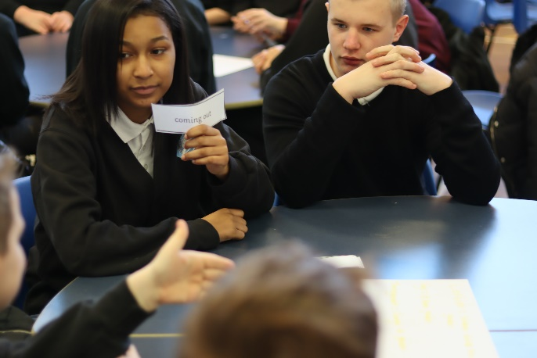

Final thoughts on pathways.

*The staff team have worked tirelessly in developing a suite of courses for our young people in phase 4 and 5 at Epinay School. We aim to offer a wide range of subjects and potential vocations for all of our young people here at Epinay in the desire to give them the skills for an independent adulthood.*

*Mr Rue*



Contact us.

* [Address](https://www.google.com/search?rlz=1C1CHBF_en-GBGB896GB896&q=epinay+school+address&stick=H4sIAAAAAAAAAOPgE-LWT9c3LMvJNjQuKNeSzU620s_JT04syczPgzOsElNSilKLixexiqYWZOYlVioUJ2fk5-coQMUBcnooFUYAAAA&ludocid=9655203376038608894&sa=X&ved=2ahUKEwibzf7quYvpAhUFZMAKHYq5D1oQ6BMwHHoECBQQAg): Nevison Avenue, South Shields, 8E34 8BT
* [Phone](https://www.google.com/search?rlz=1C1CHBF_en-GBGB896GB896&q=epinay+school+phone&ludocid=9655203376038608894&sa=X&ved=2ahUKEwibzf7quYvpAhUFZMAKHYq5D1oQ6BMwHXoECBQQBQ): [0191 489 8949](https://www.google.com/search?q=epinay+school&rlz=1C1CHBF_en-GBGB896GB896&oq=epinay+school+&aqs=chrome..69i57j0l5j69i61l2.4696j0j4&sourceid=chrome&ie=UTF-8)
* Email: [eprice@epinay.org](mailto:eprice@epinay.org) kate.simpson@epinay.org

***Happy, confident, independent learners***

***prepared for adulthood***

